## **Lab Tasks**

1. Using Row Span along with Table tag, design the following tables:

**SOLUTION:**

 <table border="1">

<tr>

    <td>item 1</td>

    <td rowspan="2">item 2</td>

    <td>item 3</td>

</tr>

<tr>

<td>item 4</td>

<td>item 5</td>

</tr>

 </table>

**OUTPUT:**

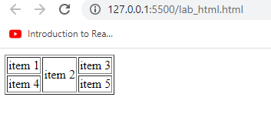

**SOLUTION:**

<table border="1">

<tr>

    <td rowspan="2">item 1</td>

    <td >item 2</td>

    <td>item 3</td>

    <td>item 4</td>

</tr>

<tr>

<td>item 5</td>

<td>item 6</td>

<td>item 7</td>

</tr>

 </table>

**OUTPUT:**

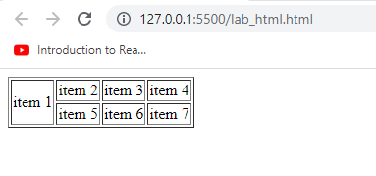

1. Using Col-Span along with Table tag, design the following tables:

**SOLUTION:**

<table border="1">

<tr>

    <td>item 1</td>

    <td colspan="2">item 2</td>

</tr>

<tr>

    <td>item 3</td>

    <td>item 4</td>

    <td>item 5</td>

</tr>

  </table>

**OUTPUT:**



**SOLUTION:**

<table border="1">

<tr>

  <th colspan="2">Head 1</th>

  <th colspan="2">Head 2</th>

</tr>

<tr>

    <td>A</td>

    <td>B</td>

    <td>C</td>

    <td>D</td>

</tr>

<tr>

    <td>E</td>

    <td>F</td>

    <td>G</td>

    <td>H</td>

</tr>

  </table>

**OUTPUT:**



**SOLUTION:**

 <table border="1">

<tr>

  <th colspan="2">Head 1</th>

  <th colspan="2">Head 2</th>

</tr>

<tr>

    <th>HEAD 3</th>

    <th>HEAD 4</th>

    <th>HEAD 5</th>

    <th>HEAD 6</th>

</tr>

<tr>

    <td>A</td>

    <td>B</td>

    <td>C</td>

    <td>D</td>

</tr>

<tr>

    <td>E</td>

    <td>F</td>

    <td>G</td>

    <td>H</td>

</tr>

  </table>

**OUTPUT:**



1. Using BGCOLOR attribute, along with ROWSPAN and COLSPAN design the following table:

**SOLUTION:**

 <table border="6">

<tr>

    <td rowspan="3" bgcolor="pink">PINK</td>

    <td colspan="3" bgcolor="red">RED</td>

</tr>

<tr>

    <td bgcolor="GREEN">GREEN</td>

    <td bgcolor="YELLOW">YELLOW</td>

    <td bgcolor="WHITE">WHITE</td>

</tr>

<tr>

    <td colspan="3" bgcolor="purple">PURPLE</td>

</tr>

</table>

**OUTPUT:**

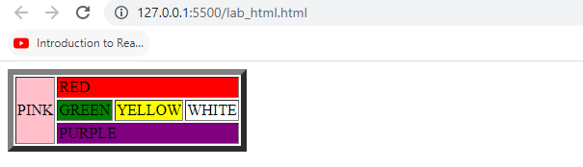

1. Using IMG tag, along with CellSpacing and CellPadding tag, design the following :
2. CellPadding=10
3. Cellspacing=10
4. Cellpadding=10, Cellspacing=10

**SOLUTION:**

 <style>

        img{

            border: 2px solid black;

            padding: 10px;

            margin: 10px;

        }

    </style>

</head>

<body>

  <img src="ahsan.jpg.jpg" alt="" width="350">

</body>

**OUTPUT:**

